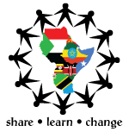
EAYC
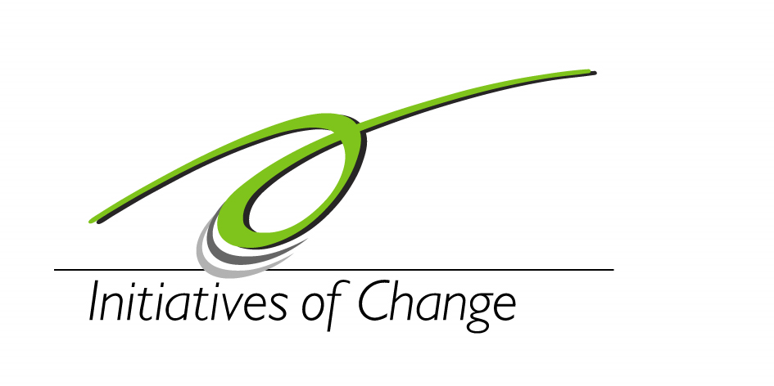
2nd EASTERN AFRICA YOUTH CONFERENCE,
POPE PAUL MEMORIAL HOTEL, KAMPALA 07-12, February, 2012
CONFERENCE THEME: YOUTH FOR PEACE…together making it happen.

DAY | Wednesday  8th February | Thursday  9th February | Friday  10th February | Saturday  11th February | Sunday  12th February
THEME: | YOUTH FOR PEACE…  together making It happen | GOOD GOVERNANCE | CONFLICT TRANSFORMATION | BUILDING SUSTAINABLE PEACE | YOUTH AND PEACE BUILDING
7.30-8.30 | Breakfast
8.45-10.00 | Opening Ceremony(8.45-11.00)  Chief Guest:Hon. Dan Kidega  Guest: Hon. Karuhanga | Reflections  (Inner Listening) | Reflections  (Unselfishness & Love) | Reflections  (Purity and Honesty) | Reflections  (Commitment)
10.00-10:30 | Tea break
10.30-12.30 | “Getting Real” (11.30-1.00)  (Open Discussion Forum) | Plenary  - Dr Godber Tumushabe  - Dan Mugera | Plenary  - Moses Monday  - Dr Arthur Bainomugisha | Plenary  - Dr Immanuel Kizza  - Dr Karambu Ringera | Closing Ceremony  Chief Guest –  King of Bunyoro
01:00-2.00 | Lunch
2.:00-2:30 | Rest
2:30-3.30 | Workshops  - Communications Skills  - Forgiveness  - Peace through Theatre  - Project Management | Workshops  - -Communications Skills  - Forgiveness  - Peace through Theatre  - Project Management | Community action | Country Presentations.  Peace building initiatives in the region | Good Bye.  Guests depart at their pleasure.
3:30-4:00 | Tea break
4:00-5:15 | Leading the way | Leading the way | Community Action | Taking it home…
5:15-6:15 | Recreational time
6:15-7:30 | Dinner
7:45-8:45 | Family Group Sharing | Family Group Sharing | Moments with MRA/IofC team UG | Gala/ Cultural night!
8.45-10.00 |  | Documentary | Documentary | Gala/ Cultural night!

