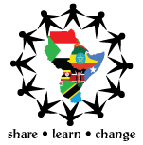
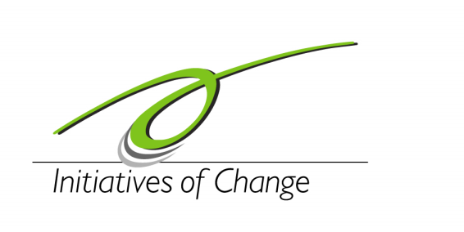
EAYF

a programme of

THE FIFTH EASTERN AFRICAN YOUTH FORUM APPLICATION FORM
HOSTING COUNTRY: SOUTH SUDAN
VENUE: JUBA AT CROWN HOTEL
DATES: 16th – 20th February 2015
Deadline :15th January,2015

Please fill the form. Personal information will be kept confidential.

PERSONAL DETAILS:
Family name: First name: Middle name:

- Tel Number(including country code): Email Address:

- Birth date (day/month/year):.…/..../.... Gender:

- Citizenship/ Passport (or ID No):

- Date of issue:.…/..../.... Date of expiry/:.…/..../....

- Country of residence:

- How did you get to know about Eastern Africa Youth Forum?
…………………………………………………………………………………………………………………………………………………………………………………………………………………………………………………………………………………………………………………………………………………………………………………………………………………………………………………………………………………………………………

- What organization or Institution are you affiliated to?
…………………………………………………………………………………………………………………………

- Please give a brief description of the Organization you are affiliated to and your position (Max 100 words).

- What do you know about South Sudan?(50 words)

- What unique contribution do you hope to make while attending the conference? (Max 100 words)

FREQUENT ASKED QUESTIONS(FAQS)

What is EAYF and why is it important?
The Eastern Africa Youth Forum (EAYF) is an annual programme that is designed to guide young visionary leaders towards ethical living and leadership within the Eastern Africa region (Kenya, Uganda, Tanzania, Rwanda, Burundi, South Sudan, North Sudan, Somalia and Ethiopia.) It is a programme of Initiatives of Change (IofC), a network of people committed to the transformation of society based on change in individuals starting with themselves.
Participants are challenged to examine their relationships and role in society through times of reflection, plenary sessions, workshops and community work. They are encouraged to look at their own hopes, fears and motivations and examine their relationships with an aim to make a collective search for answers to common issues and concerns faced in the region.

Who is organizing EAYF 5?

Eastern Africa youth forum planning team in partnership with Youth in Solidarity

Who can participate at EAYF?

Young people aged between 18 and 35 from Eastern African region and guests from other parts of Africa and the world

What will be discussed at EAYF5?

DAY ONE : 16th February 2015

Opening ceremony and workshops on: Entrepreneurship ,HIV/AIDS, Trust Building

DAY TWO: 17TH FEBRUARY 2015

Plenary sessions on :Diversity,Patriotism,Identity & Communication
Workshops on : Entrepreneurship ,HIV/AIDS, Trust Building
- DAY THREE : 18TH FEBRUARY 2015

Plenary sessions on: Innovation, Youth Unemployment, Agro-life & Climate Change

- DAY FOUR: 19TH FEBRUARY 2015

Plenary sessions on: Democracy, Human Right& Regional Relations (EAC/GL)

- DAY FIVE :20TH FEBRUARY 2015

Plenary sessions on: Forgiveness, Inner Development, Trauma Healing & Youth as Peace Agents

What are the Objectives of EAYF5 ?
1. Create a Central support system for young Eastern Africa leaders to address common issues faced in the region.
2. Share Experiences, learn from each other and emulate best practices.
3. To encourage transparency and Accountability in the young Eastern Africa minds as they aspire to take up leadership opportunities.
4. Create a harmonious and prosperous region that other countries in Africa and beyond can emulate.
5. Support the MDG’s by creating awareness

- Any special need(s)/ Diet? If yes, explain.
………………………………………………………………………………………………………………………………………………………………………………………………………………………………………………………………………………………………………………………………………………………………………………
- What if I need special medical assistance to attend EAYF 5?
All delegates who need special medical assistance are requested to write to secretariateayf5@gmail.com in advance.
- VISA
All international delegates will need to pay the entry visa fees and in case of additional information please contact EAYF5 coordinator Mr Joseph Deng at the following email : zanzonideng87@gmail.com and copy the EAYF5 secretariat at the following email: secreatariateayf5@gmail.com

- PARTICIPATION FEES

I am aware that the conference participation fee is USD 200 (exclusive of transport to and from the venue and to and from South Sudan ) and is payable on arrival on the 16th of February 2015 before entering the room. I am also aware that I am required to bring a traditional clothes from my country for the cultural gala night. Departures will be on 21st at, unless there is a special case to point out.

Signed by ……………………………………………………..

Date: ………………………………………………………..

