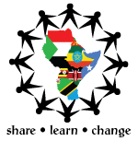
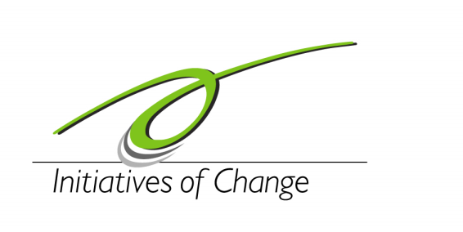
EAYC

a programme of

APPLICATION FORM
2nd EAYC FORUM, Kampala – Uganda,
7th – 12th February 2012.
Please complete in full. Personal information will be kept confidential.

Name:
FAMILY NAME FIRST MIDDLE

Fax/Tel Number: Email Address:

Birth date (day/month/year): Gender:

Citizenship: Passport No:

Date of issue: Date of expiry:

What organization or Institution are you affiliated to?

Please give a brief description of the Organization and your position (Max 200 words).

How do you think the youths can make peace happen in the Eastern Africa Region? (Max 250 words)

What unique contribution do you hope to make while at the conference? (Max 200 words)

Any special need(s)/ Diet? If yes, explain.

I (NAME)………………………………………………. Confirm that I am between 18-35years of age and from the Eastern Africa Region (Kenya, Uganda, Tanzania, Rwanda, Burundi, Ethiopia, Somalia, North Sudan and South Sudan). I am also aware that the actual conference fee per delegate will be Ush 600,000 Uganda shillings or USD 220 (for meals and accommodation) and that I am expected to pay a commitment fee of Ush. 150,000 or USD 60 before December 10th 2011.

