Making Democracy Real Dialogue 2014
Dialogue Theme: Role of Clergy and Faith in Making Democracy Real
About Initiatives of Change, IofC
Who We Are
Initiatives of Change (IofC) is a world-wide movement of people of diverse cultures and backgrounds, who are committed to the transformation of society through changes in human motives and behaviour, starting with their own.
We acknowledge that many of the world’s problems – and their solutions – are rooted in human nature. Fear, hate, greed and indifference perpetuate injustice, poverty, conflict and environmental destruction. Yet it is also in human nature to be compassionate, courageous and creative. People can live the change they wish to see.
Our Vision
A just, peaceful and sustainable world to which everyone, responding to the call of conscience, makes their own unique contribution
Our Mission
To inspire, equip and connect people to address world needs, starting with themselves.
For More Details: www.iofc.org

Introduction to Clean Election Campaign 2014
To find answers to pertinent questions, one must deliberately ask the right questions.
The stage is set to discover what makes democracy real and how the clergies can leverage on their platform to strengthen the democracy of the Nation. The platform is set for clergies to find consensus perspective as to how we can contribute to a clean Election process in the nation? And hence, build a stronger democracy for the Nation from the grass root.
Initiatives of Change, Nigeria will be hosting about 30 Clergies in Nigeria in an open dialogue towards engineering a better democracy in the largest black nation in Africa. Our focus is to engage these top leaders among Clergies in a discussion towards 'Making Democracy Real '.
The leadership of the Mosques, Clergies among Islam brotherhood, the leadership of the Church and other leaders of the Christian communities are invited for this strategic dialogue and open discussion on the subject. Learning from the Nation's Democracy’s Journey, participants will have to draw a structure on the causes and effects of the past events; the dialogue will reflect on the lessons of the journey so far and the challenges and opportunities that lay ahead. MDR 2014 will be staged at the most populated city in Nigeria - Lagos State.
Welcome to LAGOS, NIGERIA

Media Partners: Our Voice | The people

The Host
Victor Douglas Malasowe is one of the IofC Dialogue Hosts and a Religious trainer. He is a Chartered Public Relations Executive who currently serves as the President and Chairman of in Council, Lagos Chapter of Chartered Institute of Public Management.
Victor serves as the Initiatives of Change, Nigeria content lead and has hands on deck experience in facilitating discussions. He is also the director of information, Societal Development and Peaceful Co-existence Initiatives, Nigeria.
The Project team has worked out partnership with few Media Houses and organization to air the opinions of the clergies and our stand after the dialogue.
We hope to develop contents, articles and write ups through the services of our Repertoires; these will be sent to the media partners for publishing.
Our short video will also be produced for documentation and the purpose of personal enlightenment.

About the Participants
Get spurred & excited to meet other participants from various churches, mosques and other religious societies.
Thanks to stakeholders from Muslim society, churches, Christian association and Islamic Sects and YOU, we have seeded the right persons for the Dialogue.
We respect your feats of spiritual achievements. You're worth the Invite.
We anticipate a happy ending. Hence, a toast to successful deliberations!!
Objectives
- Defined how the religious bodies can engage the people towards championing better democracy
- Creates the needed platform where key players among clergies can connect to inspire change
- Accommodates different opinions and thoughts on the subject of societal leadership and governance
- Leaves every participant with a bigger question of what is yet to be done

WHAT TO EXPECT
The Dialogue is an open discussion on the subject of good governance and democracy in Nigeria. We are focused on understanding how faith can influence the society.
30 Clergies | 1Room |Different Opinions | One Solution
The Dialogue contents will be recorded and documented by the Repertoires which will in turn be developed for the Media houses. Varying Perspectives and Opinions will be discussed, solutions will be provided and recommendations for societal development will be adopted.
Programme Highlight
- Arrival of Discussants/Short Networking Session/Tea Break Session
- Short Interviews with First Five Discussants to Arrive
- Introduction of Participants
- Introduction of Host/Facilitator
- First Phase of the Dialogue
- Lunch
- End Phase Dialogue
- Pictures and Adjourning
- Last Interviews

Let's work together to inspire, equip and support change makers around the world. We are on the lookout for great collaborators to make an impact in the world.

Description to the Dialogue Centre
From Obalende Garage, board a bus/cab to Parkview, Banana then highlight at Wheatbaker Hotel(Tell the Driver you would like to locate WheatBakers hotel). Beside the hotel on left is a street called Mosley Road, enter the road and locate the Second gate by your right.
Address: 4, Onitolo Road, Via Mosley Road, Ikoyi Lagos, Nigeria
Time: 10:00am
We can’t achieve a lot a lot with the ‘African Time’ Mentality

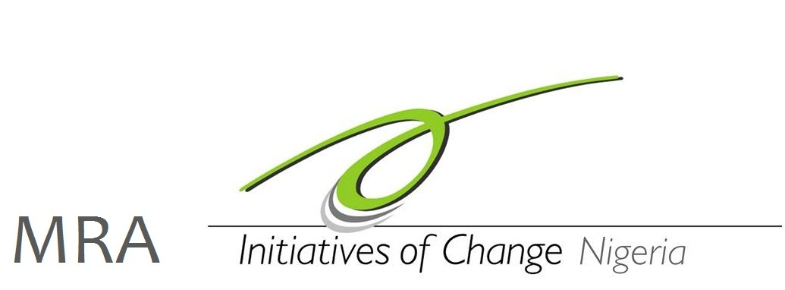
For More Information, Speak with US…….
E. admin.nigeria@iofc.org
M. +234-806-3576-947

